Standard Test Plan Template for Future Releases (Post 3.0)

Motivation

- Clear knowledge of product quality
- Identify potential areas of improvement based on defects
- Easy transition for new testers

Steps

- Copy the template file (test_case_template_final.xls) to your local drive and rename it appropriately (e.g. caCORE_SDK_test_case.xls)
- Fill relevant information (described later)
- Review and approve the document.
- Place it on the intranet in the appropriate area.

Details

The template has following worksheets:
- Master Information
- Test Cases
- Execution Summary
- Reviewers
- Instruction
- Document Control

Master Information Worksheet Instructions

The following screenshot shows the content of this worksheet.

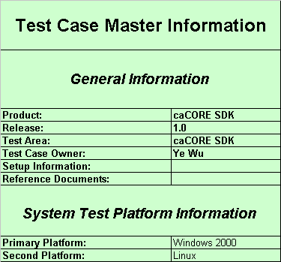

Instructions on filling the required information:

Product Field
Field should contain product name exactly as it appears in TestTrack. For ex: use caCORE SDK

Release Field
Update this field with the Release number you will be testing against. Use the release number exactly as it appears in Test Track.

Test Area Field
This field indicates the "subject" of your test cases. If you are using one test case document for all features in a given release, please use the same value as contained in the Product Field.

Test Case Owner field
This should be updated with the name of the person that will be writing/running the test cases. If this is more than one person, please list only the "primary" owner.

Set-up information
Detail any special set-up requirements for testing that are required for all test cases (For ex: specific test database needed). Individual test cases should still contain set-up information that pertains directly to that test case.

Reference Documents
List any and all documents (and their locations) used as source material for building the test cases
System Test Platform Information

This template will accommodate up to two (2) platform combinations. A platform combination is defined as a server platform and a database platform (e.g., Linux and MySql). Browser versions are not tracked in the platforms as it is assumed that test cases will be spread amongst the various client workstation versions and browser versions. This degree of spreading should be determined by analyzing past releases to determine potential "hot spots."

A platform must be selected for each platform section you record results in. This is required for the formulas/execution status to calculate correctly. When a platform has not been selected and the column header reads "0" then the formulas/execution summary for results entered in that section may not be correct.

Test Cases Worksheet Instructions

This is the main worksheet which will be utilized by the test plan developer.

General Notes

- Color will be used to communicate the following:
  - BLUE FONT will be used to denote newly added test cases.
  - DO NOT enter a value in any of the tracking fields for your heading records (1.0, etc).
  - DO NOT turn off the Gridlines Setting
  - DO NOT change formatting of any of the cells.
- Place Error Handling (negative) test cases along with the "matching" positive test cases. This will provide an easy to follow sequence.
- If a list is needed in a specific cell, use Alt + Enter to generate return character.

Test Case ID

- Header sections should be numbered using 1.0, 2.0, 3.0, etc.
  - Header section examples: 1.0 Installation, 2.0 Verifying Search, 3.0 Verify Codegen
  - Header sections are not actual tests, but just the introduction to a grouping of similar tests
  - Test cases should be numbered as 1.1, 1.2, 1.3, 2.1, 2.2, 3.1, 3.2, 3.3, 3.4, etc.
- Test case example: 1.1 Add an Item entering values in all fields, 1.2 Add an Item entering values only in the required fields
- Sub-test case example: 1.1.1 Add an Item entering all values in fields with all lower case characters
- If you need to add a test case, just add it to the end of the section assigning it the next sequential ID number. DO NOT reuse an existing test case number.
- DO NOT create sub-test cases for a sub-test case

Priority Numbering

This is used to determine how the test case should be prioritized based on criteria such as:
A) How critical is the condition being tested? -OR- How much trouble will we get in if the test case fails?
B) How much testing could be blocked if the test case fails?
C) How many areas could be affected by any defect fixes?
D) How complicated a fix will be required to fix the defect?
E) How likely is a customer to run into this scenario?
All test cases must have a priority.
Priorities are numbers. Only 1, 2, and 3 are acceptable.

Priority 1
Priority 1 test cases are those test cases that could either block large areas of testing or could affect critical areas of functionality if a fix is applied. For example, being able to install the application should be marked as Priority 1. Integration Test Cases should generally be marked as Priority 1. Basic system object creation test cases should also be classified as Priority 1.

Priority 2
General test cases that have medium impact on system. Most test cases will fall into this category.

Priority 3
This priority should be used for low risk areas of test. This can include rarely encountered error messages or test areas that have never broken.

Requirement ID

Enter the ID of the Requirement from the Requirements Specification document provided by Project Management if available.

Purpose

Define the condition being tested, such as "Verify 'No Data' view is displayed correctly in worksheet" or "Import a product using a comma delimited data file."

Prerequisite

List any prerequisites or preconditions that must be met before the test case can be run successfully. For example, "A gene must be defined" or "User must have a valid password"

Procedure

List the general steps necessary to perform the test case. These procedures should be detailed enough so that someone new to the testing area can run the test case. The procedure should not detail every nuance. It is expected that the tester executing the tests has a basic understanding of the system and test area.

Expected Result

Explain what observable results the tester should expect to see after the test case procedure has been completed. This includes results that are viewed in the GUI, data saved to the database, and etc. The expected results should be detailed enough so there are no questions as to whether the test case has passed or failed.

Platform Sections

Two platform combinations have been provided. The three header columns should NOT be directly modified under any circumstances. These are populated automatically based on the platform settings in the Master Information worksheet.

Each platform section has a column for identifying which test cases must be run during different key stages of the system test cycle: Integration (Test Readiness Evaluation), System Test. This enables tracking the status of the cases separately during each of these stages. Placing a "Y" in the Required Column for each stage indicates the test needs to be run during the specific stage of the test cycle for that platform. An "N" or blank means the test case is not required for that stage/platform. This field is used to compute the metrics described in the “Execution Summary” worksheet.

Each platform section has columns for marking the status of test cases during different key stages of the system test cycle as well. Enter a "P" if the test case passed or an "F" if the test case failed. A "D" can be used to note test cases that are being deferred when it is determined they either cannot or should not be fixed at this time.

Integration Test Section

Each platform section has a column for identifying integration test cases that need to be run to certify the application is ready for System Test on that platform. (Run during Test Readiness Evaluation)

Integration Required
If the test case MUST be run for integration test on this platform, enter a "Y" in this field. If it is not to be used as an integration test case on this platform, leave this field blank.

Integration Pass

Update the Pass field only once the test case has been executed. Enter a "P" if the test case passed or enter an "F" if the test case failed. A "D" can be used to note test cases that are deferred during execution; however if a test case is being deferred at this point it should probably be removed as an Integration Test rather than being deferred. The D option was provided only for consistency in formulas.

System Test Section

Required Column
If a test case is marked with a "Y" the test case must be executed on this platform. If the test case is marked with an "N", the test case should not be executed on this platform. If there is a blank in this column, the execution of this test case is optional. Values of "Y", "N", and " " (blank) are the only valid values for this column.

Pass Column
Update the Pass field only when the test case has been executed. Enter a "P" if the test case passed or enter an "F" if the test case failed. If the issue has failed and has been deferred for a later release, please enter a "D" in this field.

Execution Summary Worksheet Instructions

This sheet does not require any editing. Based on information provided in the other sheets, it computes the following QA metrics for each platform:

- Number of test cases defined
- Number of test cases executed
- Number of test cases successful
- Number of test cases deferred
- Percentage of test cases executed
- Percentage of test cases successful (of defined)
- Percentage of test cases successful (of executed)
- Percentage of test cases deferred.

The above metrics are further broken down for following criteria:
- Based on priority
- Integration test
- System test

Reviewers Worksheet Instructions

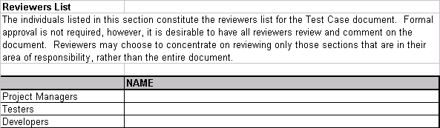

Document Control Worksheet Instructions

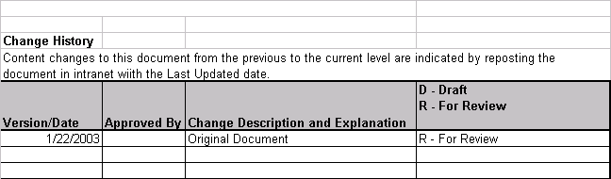

Instruction Worksheet Instructions

This sheet contains all the instructions presented in this document for individual worksheets.

